Learning Report
Organisation layer



Document History
Revisions

Version | Status | Date | Changes
0.1

Contents sopgave
1 Introduction 5
2 Fundamentals 6
3 Exercises 7
3.1 Networking 8
3.1.1 Requirements 8
3.1.2 Elaborations 8
3.1.3 Security 8
Servers & Operating Systems 9
3.1.4 Requirements 9
3.1.5 Elaborations 9
3.1.6 Security 9
3.2 First step to the cloud 10
3.2.1 Requirements 10
3.2.2 Elaborations 10
3.2.3 Security 10
3.3 Virtualization and containerization 11
3.3.1 Requirements 11
3.3.2 Elaborations 11
3.3.3 Security 11
3.4 Hardware 12
3.4.1 Requirements 12
3.4.2 Elaborations 12
3.4.3 Security 12
3.5 Identities and cloud security 13
3.5.1 Requirements 13
3.5.2 Elaborations 13
3.5.3 Security 13
4 Workshops 28-3-2025 – OnePager 14
5 Practice 15
6 Resources 16
7 Image Register 17

Introduction
My name Is Ivaylo Bakardzhiev, 22 years old From Sofia, Bulgaria and I came in The Netherlands so I could study at Fontys because aftter some researech it turned out to be one of the best Universities for applied science in Europe. In my previous education I had only a glipmse of ICT but I was sure that I wanted to follow a career into this direction.
The reason I decided to to study infrastructure was because one of my friends in semester 4 had cybersecurity as a specialisationand he was was taught about different aspects of cybersecurity like ethical hacking, pen testing and different ways of cyber attacks. That took my interest imeddiately .
My knowledge and experience in that certain specialty currently are very basic, but I'm looking forward to improving my skills and knowledge because my idea for the near future after successfully graduating Fontys is to work as a pentester.

Exercises

Networking

Requirements

Requirement | Chosen solution | Elaboration

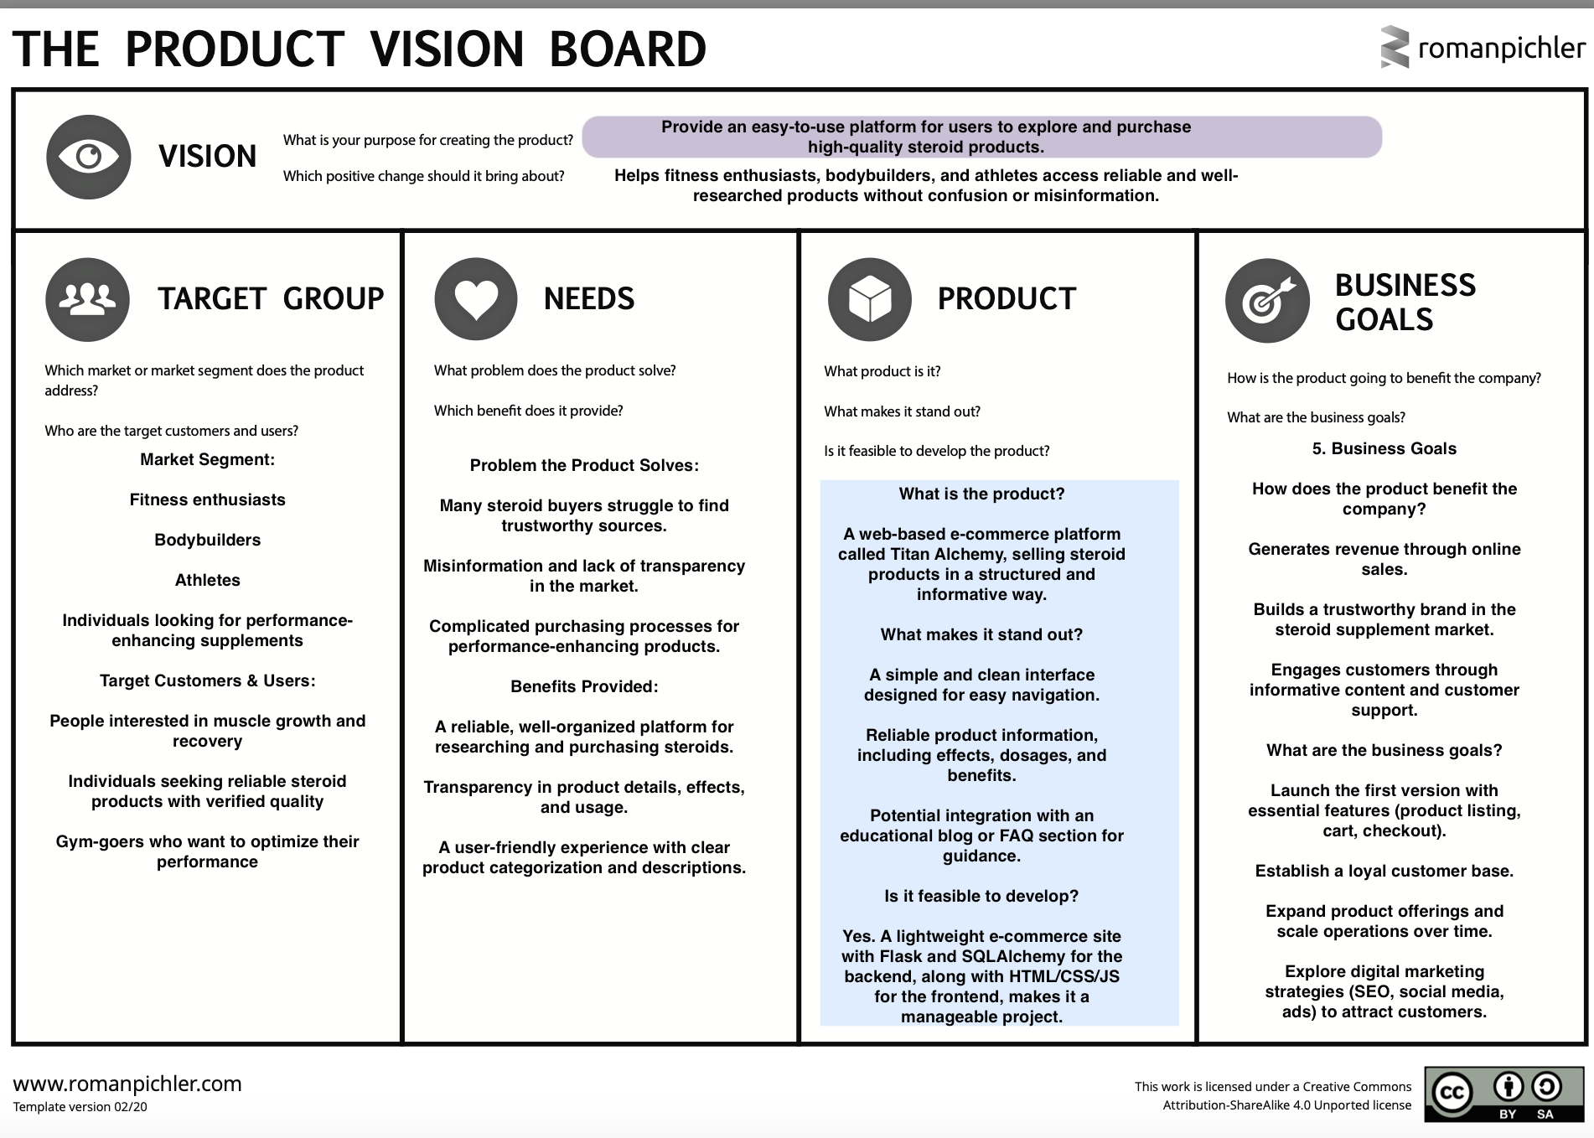


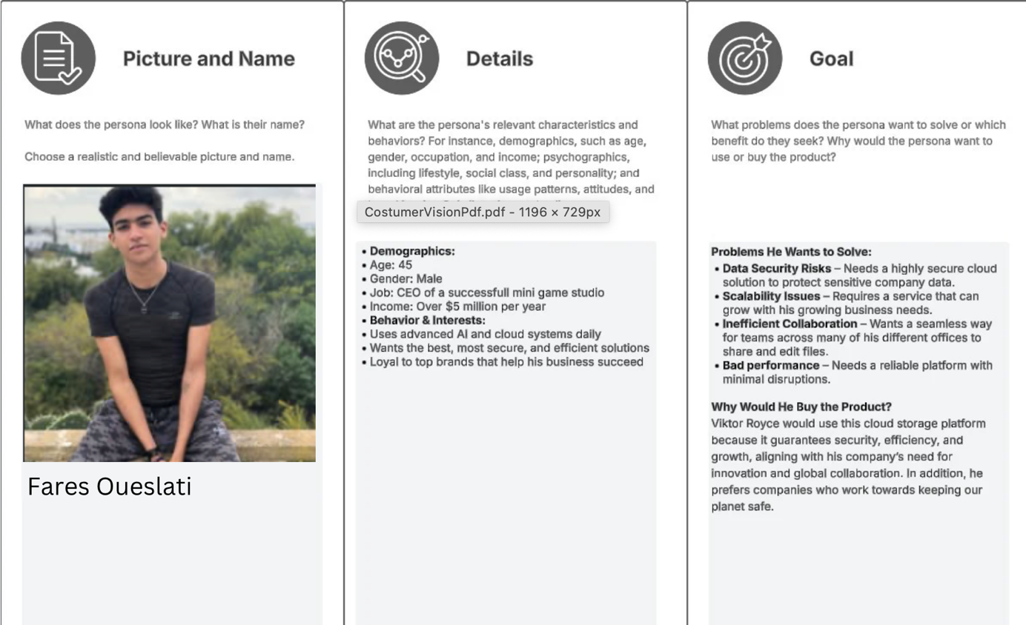
Ivaylo Bakardzhiev

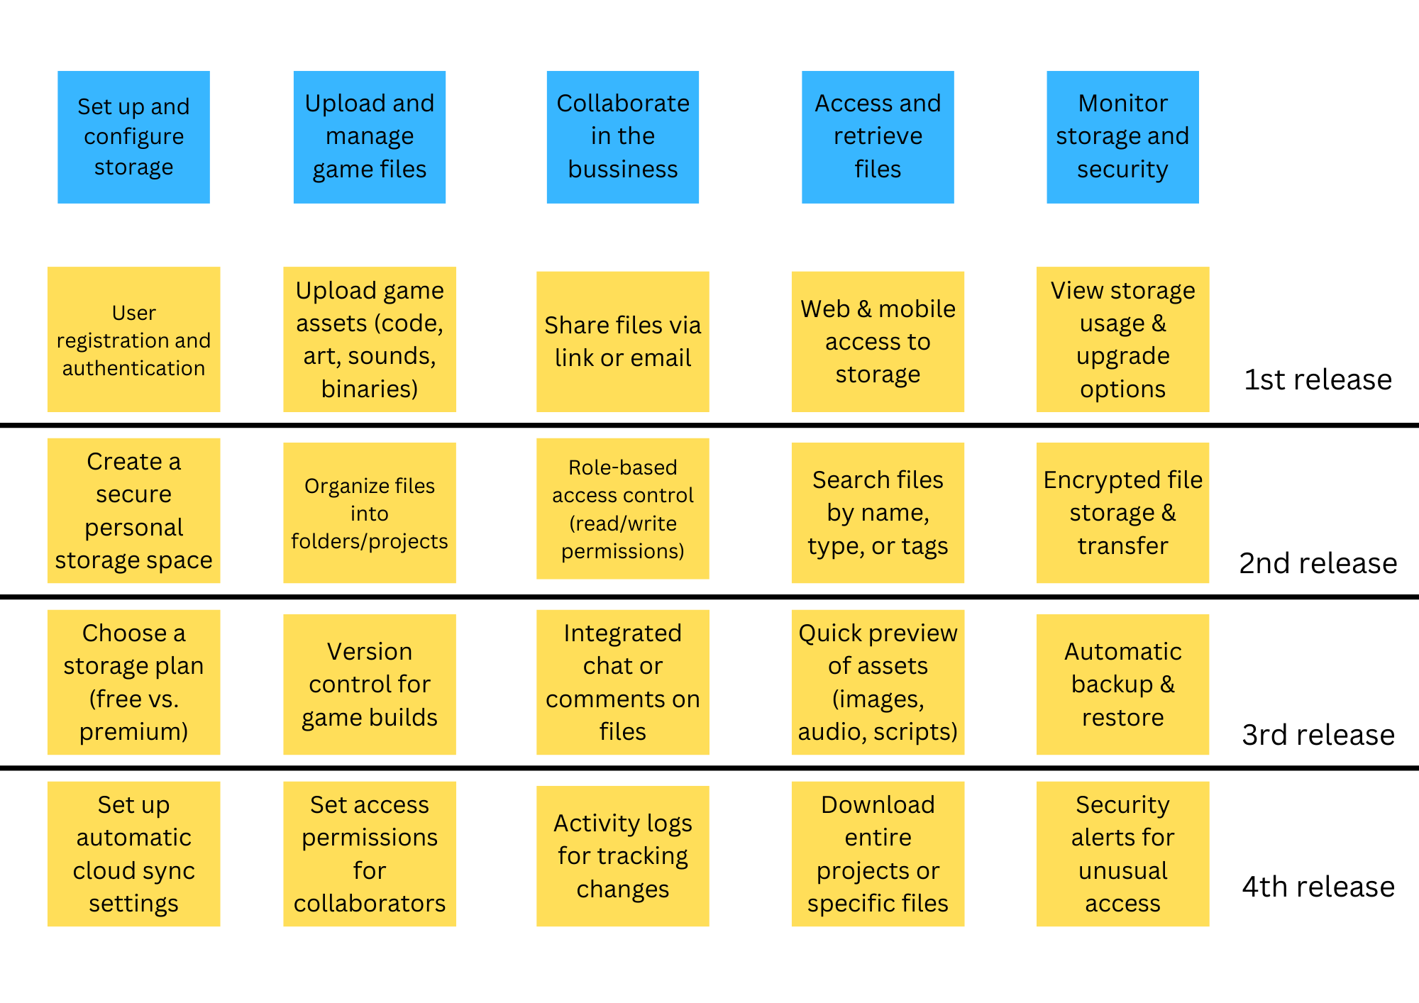

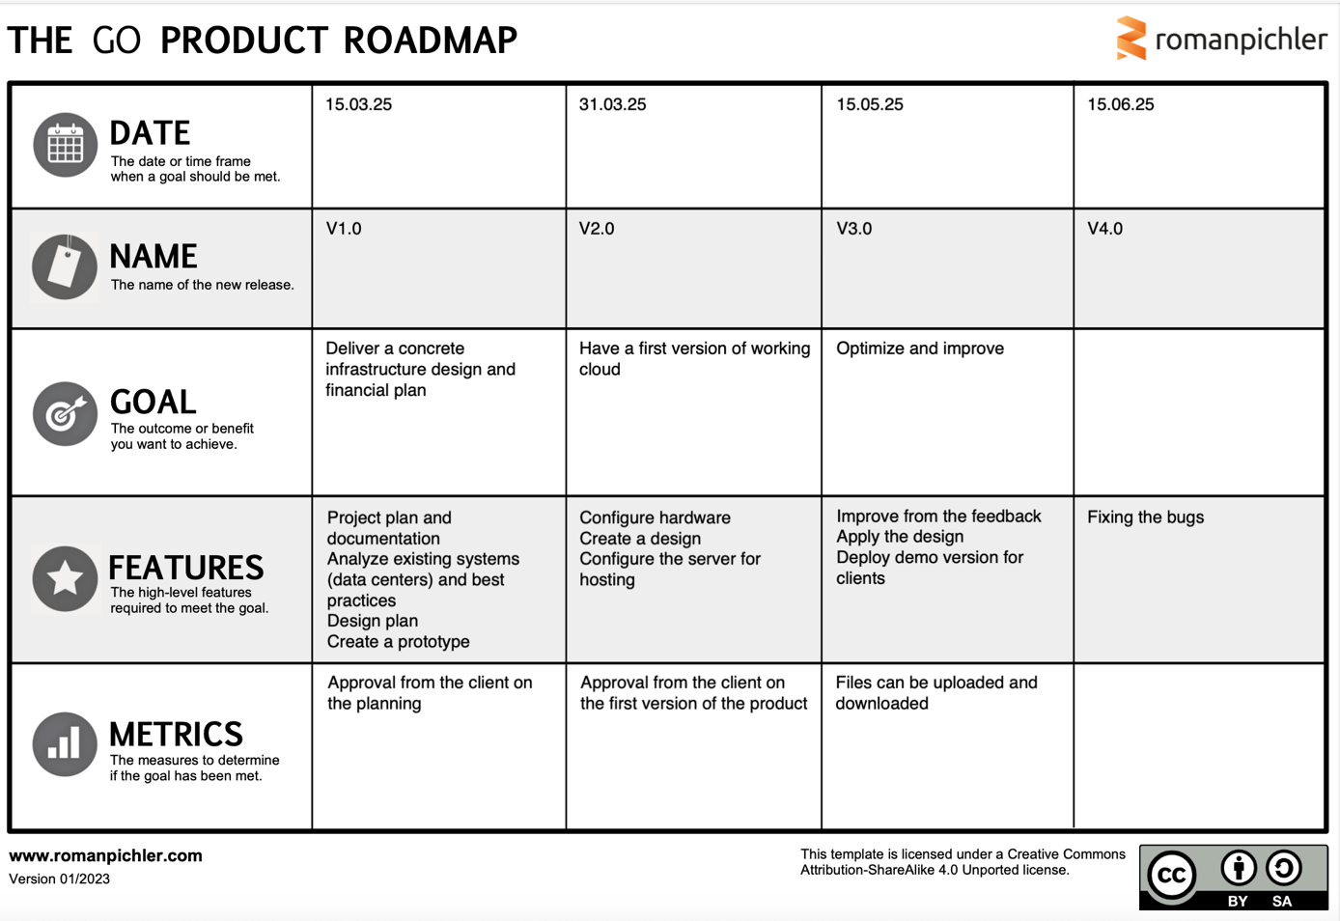

Elaborations

Security
ITL Assignment
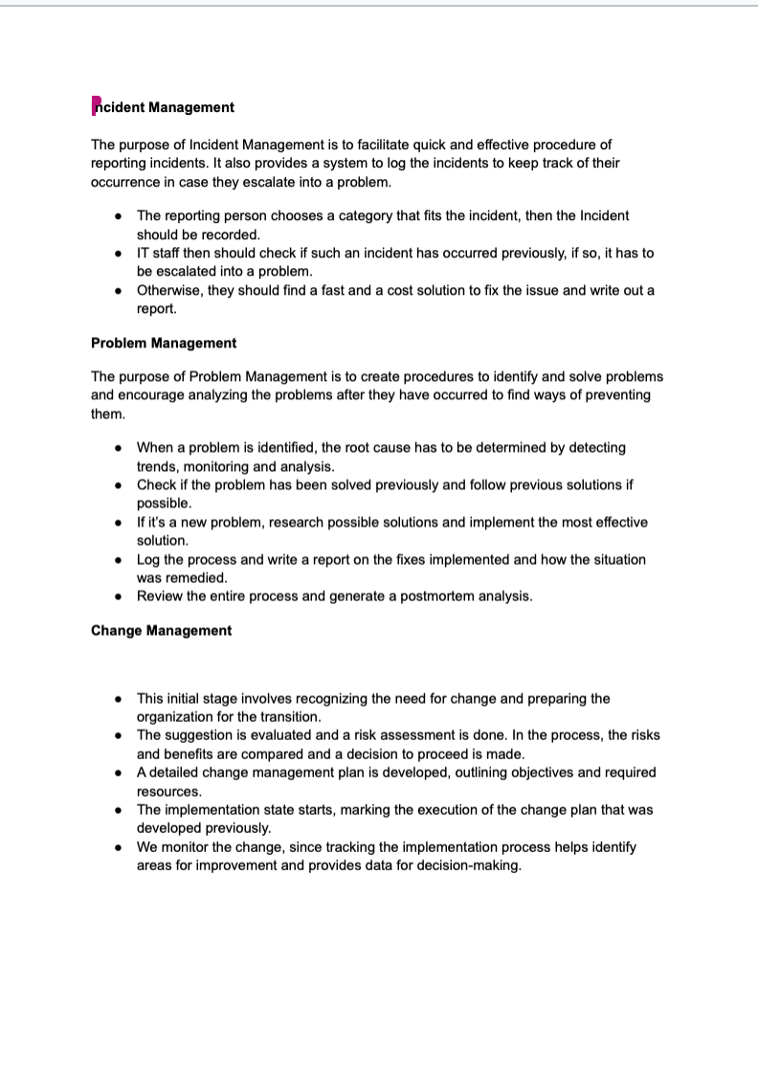

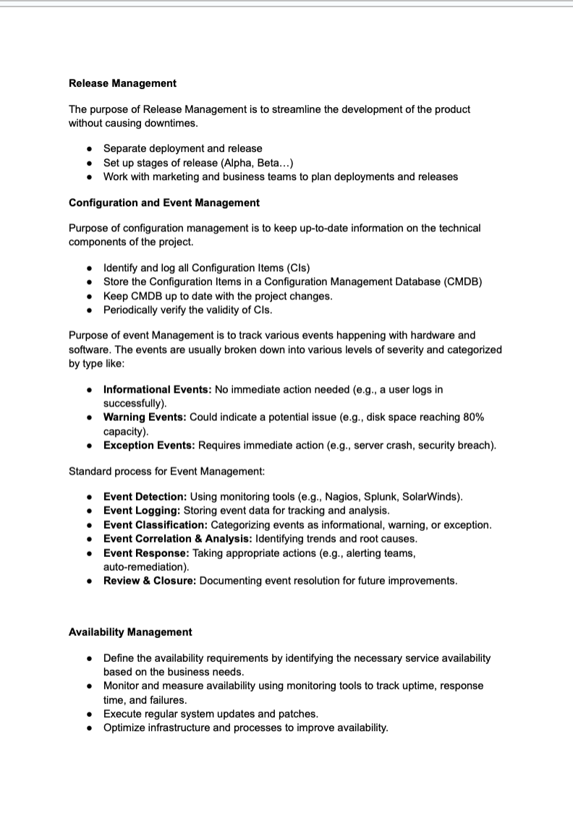
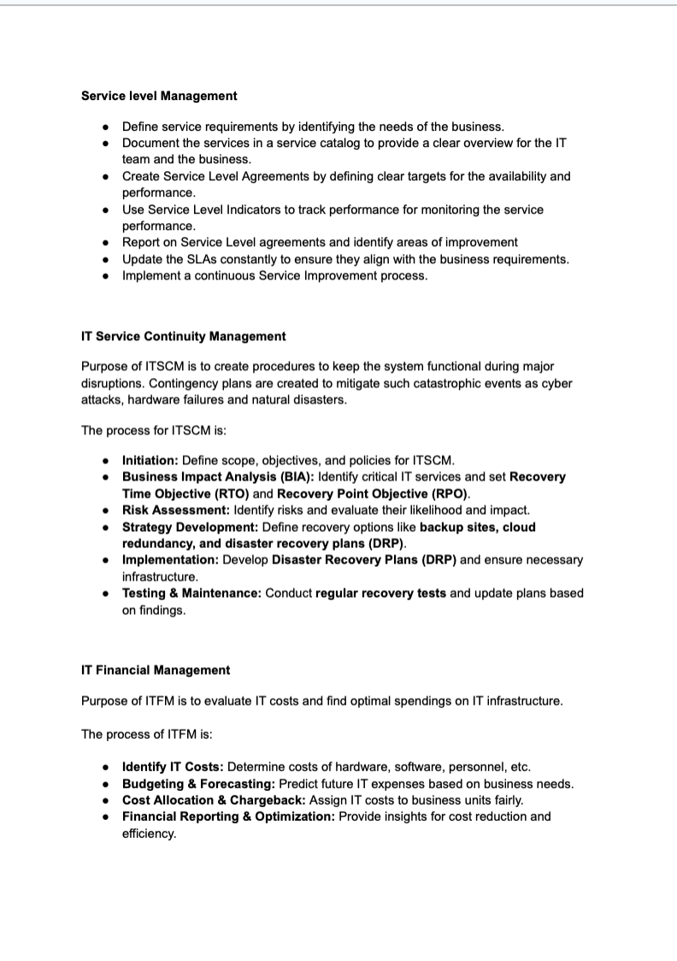
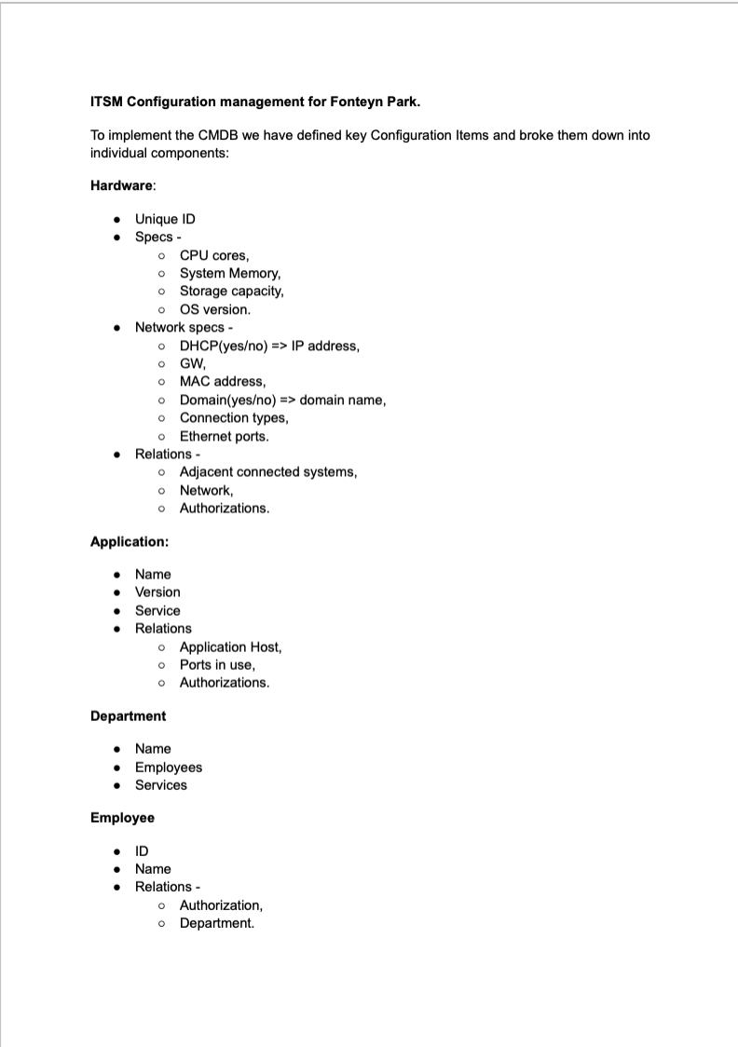
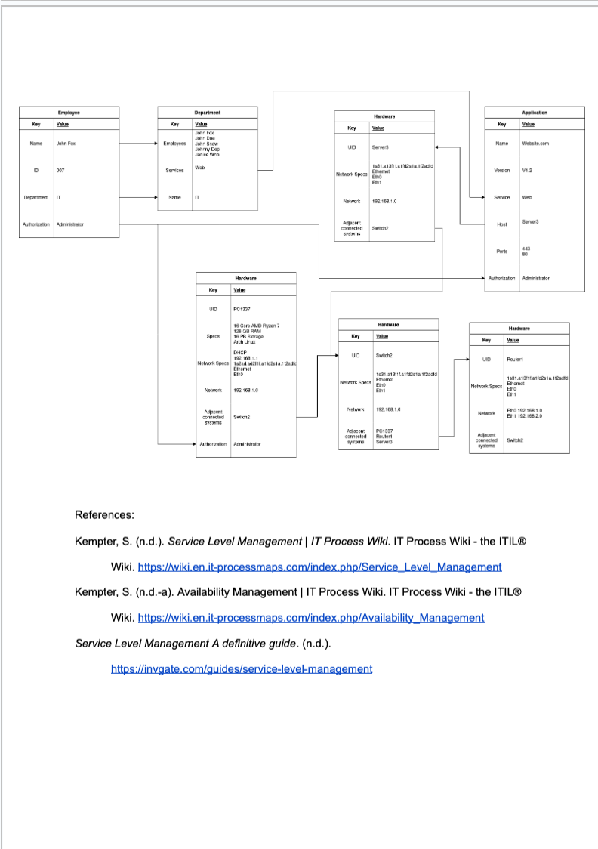

Servers & Operating Systems

Requirements

Requirement | Chosen solution | Elaboration

Elaborations

Security

First step to the cloud

Requirements

Requirement | Chosen solution | Elaboration

Elaborations

Security

Virtualization and containerization

Requirements

Requirement | Chosen solution | Elaboration

Elaborations

Security

Hardware

Requirements

Requirement | Chosen solution | Elaboration

Elaborations

Security

Identities and cloud security

Requirements

Requirement | Chosen solution | Elaboration

Elaborations

Security

Workshops 28-3-2025 – OnePager
Create a 1-page content elaboration here about the workshop(s) you participated in.

Practice
In addition to creating exercises, we think it is important that you start applying your knowledge. Applying your knowledge is also a prerequisite for taking steps on the developmental scale. You do this primarily in the pro task, but you may post elaborations here of work you have performed elsewhere. Just make sure that the technical work you do is well documented.
Create a separate paragraph for each topic or theme you will work on within the pro task. At the beginning of each paragraph, provide a good introduction stating exactly what you are going to do and why.
Work for the POP includes this.
You can delete this text.

Resources
There are no sources in the current document.

Image Register
Geen gegevens voor lijst met afbeeldingen gevonden.

